Multiple-choice section

|  |  |  |  |  |  |  |  |  |  |  |  |  |  |  |  |
| --- | --- | --- | --- | --- | --- | --- | --- | --- | --- | --- | --- | --- | --- | --- | --- |
| Question | 1 | 2 | 3 | 4 | 5 | 6 | 7 | 8 | 9 | 10 | 11 | 12 | 13 | 14 | 15 |
| Answer | B | C | A | D | C | D | A | B | A | C | B | B | D | A | D |

Question 1 [6.1]

B

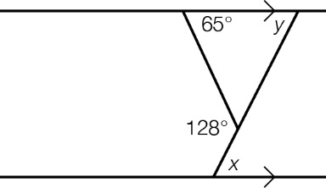

*y* = (128 – 65)° (exterior angle of a triangle = sum of interior opposite angles)

*y* = 63°

*x* = *y* (alternate angles between parallel lines)

*x* = 63°

Question 2 [6.2]

C

RHS as both triangles have a right angle (R), both triangles have hypotenuse of equal length (H) and both have matching sides equal (S)

Question 3 [6.5]

A

In ∆*ABC*, *AC* lies between the 110° angle and the 22° angle.

*FD* is the line in a matching position in ∆*DEF*.

Question 4 [6.4]

D

Length after scale factor is applied = 0.5 × 12 = 6

Width after scale factor is applied = 0.5 × 7 = 3.5

Dimensions of new rectangle = 6 cm × 3.5 cm

Question 5 [7.1]

C

The hypotenuse is the longest side in a right-angled triangle—correct

The hypotenuse is opposite the right angle—correct

The shorter side next to the reference angle is called the opposite side—incorrect

The shorter side next to the reference angle is called the adjacent side—correct

Question 6 [7.2]

D

tan(*x*) = ****

****

Question 7 [7.4]

A

tan(θ) =****

****

θ=tan-1****

Question 8 [7.5]

B

Base angle in triangle = 75° (alternate angles between parallel lines)

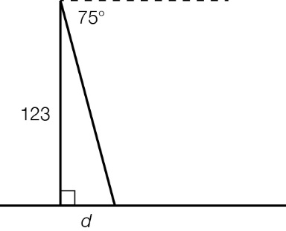

tan(θ) =****

****

Question 9 [8.1]

A

Speed is data that is measured. It is therefore continuous data.

Question 10 [8.3]

C

The class centre is the middle value in the interval 0–20. This is 10.

Question 11 [8.5]

B

Number of socks in drawer after 1 white sock is selected = 5 × 2 + 15 × 2 – 1 = 39

Number of white socks left after 1 is selected = 10 – 1 = 9

****

Question 12 [8.7]

B

List the sample space in an ordered way.

If Top 1 = T1, Top 2 = T2, and Skirt 1 = S1…, then the sample space is:

T1S1, T1S2, T1S3, T1S4, T1S5, T1S6, T2S1, T2S2, T2S3, T2S4, T2S5, T2S6, T3S1, T3S2, T3S3, T3S4, T3S5, T3S6

T4S1, T1S2, T4S3, T4S4, T4S5, T4S6, T5S1, T5S2, T5S3, T5S4, T2S5, T5S6

Top 1 will match Skirt 1 and Skirt 2.

There are 2 successful outcomes: T1S1 and T1S2. There are 30 possible outcomes.

****

Question 13 [9.2]

D

*x*2 = 14*x*– 49

*x*2 – 14*x* + 49 = 0 (this is a perfect square)

*x*2 – 2 × 7*x* + 72 = 0

(*x* – 7)2 = 0

*x =* 7

Question 14 [9.3]

A

Compare *y* = (*x* – 4)2 – 5 to *y* = (*x* – *h*)2 + *k*

*h* = 4

*k* = -5

*h* = -4 means a shift to the right of 4 units

*k* = -5 means a shift down of 5 units

Question 15 [9.4]

D

*y* = *x*2 – 3*x* + 5 is not a circle equation, as the index of *y* is not 2.

*y*= is not a circle equation, as the index of both *x* and *y* is not 2. The *x*-variable is also in the denominator of a fraction.

*y*2 *= x*2 + 3 is not a circle equation. The index of *x* and *y* = 2, but when rearranged the equation becomes *y*2 – *x*2 = 3. For a circle, the sign connecting *y*2 and *x*2 must be +.

*y*2 *=* 5 – *x*2 is a circle equation. When rearranged, the equation becomes *x*2 + *y*2 *=* 5. This is in the form of *x*2 + *y*2 *= r*2.

Multiple-choice total marks: 15

Short answer section

Question 16 4 marks [6.1]

(*x* + 12°) + (*x* + 34°) = 3*x* + 3° (exterior angle of ∆ = sum of interior opposite angles)

2*x* + 46° = 3*x* + 3°

2*x +* 43° =3*x*

*x* =43°

Question 17 5 marks [6.2]

**(a)** ∠*BAC* = ∠*CDB* (given)

∠*ABC* = ∠*DCB* (given)

*BC* is common.



**(b)** 

Question 18 3 marks [6.3]

(*x* + 15) + (2*x* + 20) + (*x* – 10) + (2*x* – 25) = 360

6*x* = 360

*X* = 60°

Question 19 3 marks [6.4]

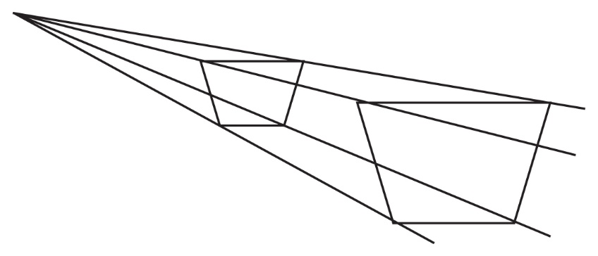

Question 20 5 marks [6.5]

**(a)**  

As the ratio of matching sides is equal, the triangles are similar.

**(b)** The scale factor is 2.

Question 21 3 marks [6.7]

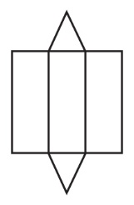

Question 22 3 marks [7.1]

**(a)** hypotenuse = 10.3 cm

**(b)** opposite side = 5.2 cm

**(c)** adjacent side = 8.9 cm

Question 23 3 marks [7.2]

**(a)** sin(θ) = 

**(b)** cos(θ) = 

**(c)** tan(θ) = 

Question 24 3 marks [7.3]

sin(37°) = 

*x* = 

*x* = 71.45 m

Question 25 3 marks [7.5]

cos(66°) = 

*d* = 15.5cos(66°)

*d* = 6.3 km

Question 26 3 marks [8.1]

**(a)** Data that is measured, such as the weight of a bag of apples, is called *continuous* data.

**(b)** Data that is counted, such as the number of people attending a concert, is called *discrete* data.

**(c)** Data that in not numerical and has no sense of order, such as the country you were born in, is called *categorical* data.

Question 27 3 marks [8.2]

**(a)** 16 packets

**(b)** No, the red jelly beans do not need to be distributed in the same proportion inside the packet. A random sample of 40 jelly beans could contain any number of red jelly beans but the mean number of many samples would approach 10.

Question 28 3 marks [8.5]

|  |  |  |
| --- | --- | --- |
| **(a)** *pq* – *rt* + *pr* – *qt*  = *pq* + *pr* – *rt* – *qt*  = *p*(*q* + *r*) – *t*(*r* + *q*)  = (*p* – *t*)(*q* + *r*) | **(b)** *y*2 – 8*y* + 4*y* – 32  = *y*(*y* – 8) + 4(*y* – 8)  = (*y* – 8)(*y* + 4) | **(c)**  =  = |

Question 29 3 marks [8.7]

**(a)** List the sample space in an ordered way. If Art 1 = A1, Art 2 = A2,… and Sport 1 = S1,… then the sample space is:

A1S1, A1S2, A1S3, A1S4, A1S5, A1S6, A2S1, A2S2, A2S3, A2S4, A2S5, A2S6, A3S1, A3S2, A3S3, A3S4, A3S5, A3S6, A4S1, A4S2, A4S3, A4S4, A4S5, A4S6, A5S1, A5S2, A5S3, A5S4, A2S5, A5S6

If origami is A1 and rock climbing is S1 then there is 1 successful outcome: T1S1. There are 30 possible outcomes.

Pr(selecting origami and rockclimbing)****

**(b)** If bushwalking is S2, then there are 8 successful outcomes:

A2S1, A2S2, A3S1, A3S2 A4S1, A4S2, A5S1, A5S2

Pr(bushwalking or rock climbing and not origami) = = 

Question 30 5 marks [9.1]

**(a)** the coordinates of the turning point: (-2, -9)

**(b)** the type of turning point: minimum

**(c)** the equation of the axis of symmetry: *x* = -2

**(d)** the *y*-intercept: *y* = -5

**(e)** the *x*-intercepts: *x* = -5, *x* = 1

Question 31 4 marks [9.2]

|  |  |
| --- | --- |
| **(a)** *x*(*x* + 4) = 0  *x* = 0 or *x* + 4 = 0  *x* = 0 or *x* = -4 | **(b)** *x*2 – 10*x* + 25 = 0  (*x* – 5)2 = 0  *x* = 5 |

Question 32 4 marks [9.3]

**(a)** *y = x*2 is inverted, is moved 5 units to the left and 6 units up.

**(b)** TP = (-5, 6)

Question 33 3 marks [9.3]

centre (-3, 1)

radius = 5

Question 34 3 marks [9.6]

*k* = 7

|  |  |  |  |  |
| --- | --- | --- | --- | --- |
| *x* | 3 | 5 | 7 | 8 |
| *y* | 21 | 35 | 49 | 56 |

Question 35 2 marks [9.7]



Short answer total marks: 68

Extended answer section

Question 36 8 marks [6.6]

∠*ABC* = ∠*ECD* = (90°)

∠*ADB* = ∠*EDC* (common angle)

∠*BAD* = ∠*CED* (corresponding angles)

∆*ABC* ≈ ∆*ECD* (AAA)



Question 37 10 marks [8.3]

(a)

|  |  |  |  |
| --- | --- | --- | --- |
| Number of people | Midpoint (*x*) | Frequency (*f*) | *xf* |
| 0–9 | 4.5 | 1 | 4.5 |
| 10–19 | 14.5 | 5 | 72.5 |
| 20–29 | 24.5 | 10 | 245 |
| 30–39 | 34.5 | 7 | 241.5 |
| 40–49 | 44.5 | 4 | 178 |
| 50–59 | 54.5 | 2 | 109 |
| 60–69 | 64.5 | 1 | 64.5 |
|  |  | 30 | 915 |

Mean = 

= 30.5

**(b)** Median class = 20–29

**(c)**

**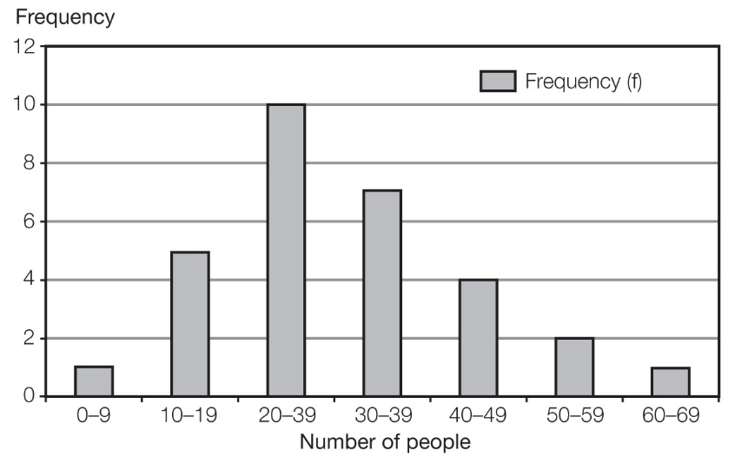**

**(d)** The data is slightly skewed to the right or positively skewed.

Question 38 6 marks [9.3]

|  |  |
| --- | --- |
| (a) (*x* – 3)2 – 1  = *x*2 – 6*x* + 9 – 1  = *x*2 – 6*x* + 8  (*x –* 2)(*x –* 4)  = *x*2 – 4*x* – 2*x* + 8  = *x*2 – 6*x* + 8  (*x* – 3)2 – 1 = (*x –* 2)(*x –* 4)  (b) *y* = (*x* – 3)2 – 1  turning point = (3, -1)  *y* = (*x* – 3)2 – 1  = *x*2 – 6*x* + 8  *y*-intercept = (0, 8)  *y* = (*x* – 3)2 – 1  = (*x –* 2)(*x –* 4) from **(a)**  *x*-intercepts:  *x –* 2 = 0  *x* = 2  (2, 0)  *x –* 4 = 0  *x* = 4  (4, 0) | ACPM9_PR_se2S_q38 |

Extended answer total marks: 24

TOTAL test marks: 107